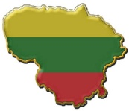
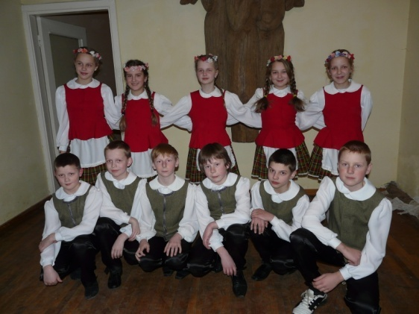
TRADITIONAL LITHUANIAN DANCES AND COSTUMES
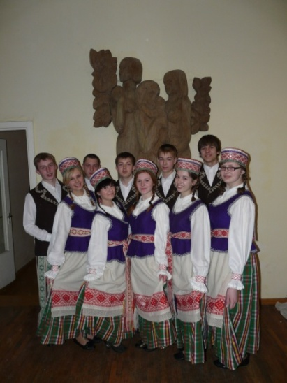
The evolution of Lithuanian dance is closely linked to the country's history of occupation and independence. In the 21st century, Lithuania, as an independent nation, enjoys the celebration of a wide variety of dances including ballet, modern and national folk. Dance is on display in numerous festivals held throughout the country.

One style of Lithuanian folk dance is called circles (rateliai), a type of dance in the round. Prior to the 19th century, the dances were performed without musical accompaniment.
The dancers of the 6th form
The traditional costumes of Lithuanian folk dancing are quite colorful, making use of vibrant blues, reds, greens and yellows. Based on ethnographic style, these 19th century peasant costumes are designed to represent various regions of the Lithuanian countryside.
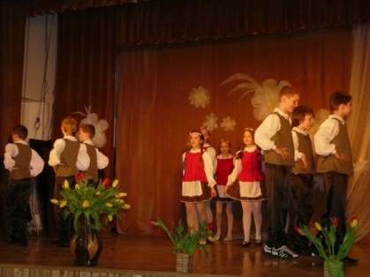
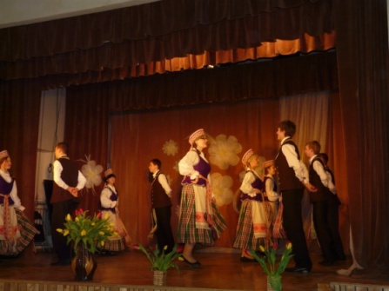
The really deep and rich Lithuanian dance heritage formatted the nowadays dancing culture which is characterized by inward emotional energy. Typical Lithuanian dance has a music of moderate tempo, symmetric jumps of not very large interval. The most famous paired Lithuanian dances are polkas, grinders, dances named “Šokinėkit, berniukai“ (Jump, Boys), „Kiškelis“ (The Bunny), „Pjoviau šieną“ ( Cut the Hay) and so on. The main movements and steps do not differ much from those of neighboring countries, however, Lithuanian folk dance owns a unique character.
The dance group of Naisiai Basic school
[Type a quote from the document or the summary of an interesting point. You can position the text box anywhere in the document. Use the Text Box Tools tab to change the formatting of the pull quote text box.]

Lithuanian dance “Jievaro tiltas”
Lithuanian dance “Rolenderis”

The Lithuanian Song and Dance Celebration (Dainų šventė) ,which is more than 100 years old, is an undoubtedly significant Lithuanian cultural tradition and it is even included into the UNESCO World Heritage list as to be an accredited world-line cultural worth. (See more http://www.way2lithuania.com/en/travel-lithuania/dance).

