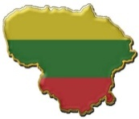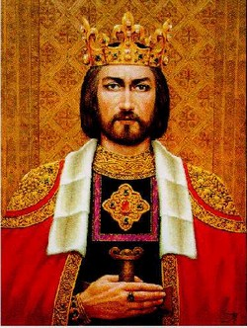**LITHUANIAN NATIONAL HOLIDAY**

* **1st January**   
  New Year’s day  
  The day of Lithuanian flag
* **16th February** Day of Restoration of Lithuania’s Independence
* **11th March**  
   Day of Restoration of Independence of Lithuania
* **8th April**   
  Easter
* **6st May ( first Sunday )**  
  Mother’s day
* **24th June**   
  Feast of St.John
* **6th July**   
   Lithuanian national festival, the first Lithuanian ruler king Mindaugas’ crowning day.
* **15th August**  
  The Feast of the Assumption of the Blessed Virgin Mary
* **1st September**  
  The beginning of school year
* **5th October**  
  Teachers’ day
* **1st November**  
  All Saints Day
* **25th December**  
  Christmas



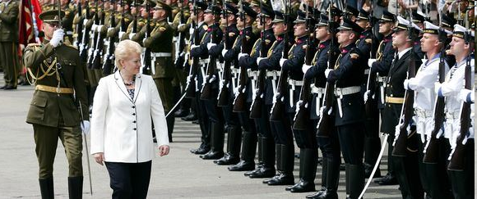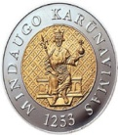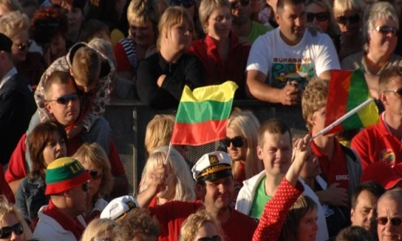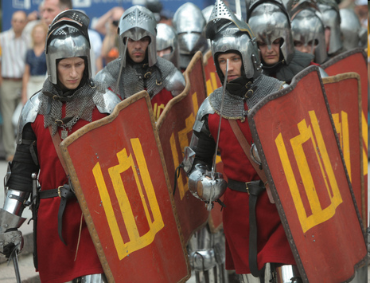

***People in the capital and in the smaller towns celebrate this national festival reminding the past of Lithuania and its traditions. The President of Lithuania Dalia Grybauskaitė makes a speech on that day. On the 6th of July the President Dalia Grybauskaitė honours the worthy people of Lithuania and gives them medals. It’s a tradition among the Lithuanians in all over the world to sing Lithuanian anthem at 9 pm on that day.***

***The 6th of July - Lithuanian national festival, the first Lithuanian ruler king Mindaugas’ crowning day.* *The first and the only Lithuanian King was crowned on the 6th  of July, 1253. Lithuanian King Mindaugas united Lithuanians and made one nation.***